SciToVation
Toxicology Literature Review Platform
Architecture & Operating Guide
A non-technical walk-through of the MCP-powered pipeline
that turns a chemical name into an evidence-backed report.
Prepared for client review
April 2026
Aditya B Yadav | SciToVation

Table of Contents

Executive Summary
The SciToVation Toxicology Literature Review Platform is an automated research assistant that takes a single chemical name and, in one command, produces a fully cited Microsoft Word report on its known health effects. It searches fourteen public scientific databases in parallel, scans every document for one hundred and sixty-nine toxicology keywords, scores each piece of evidence, and assembles the results into a structured narrative.
This document explains how the platform works from end to end. It is written so that a non-technical reader can follow the full journey of a request, while still including the exact numbers, flow diagrams, and safeguards that a technical reviewer will want to verify.

Key Facts at a Glance
Entry point | One MCP tool: build_chemical_review(chemical)
Tools exposed | 32 MCP tools (all callable by Claude as skills)
Data sources | 14 public scientific / regulatory databases
Keywords scanned | 169 terms across 15 toxicology categories
Parallel workers | Up to 8 concurrent HTTP fetches, 16 TCP connections
LLM calls during harvest | Zero — the harvest stage is fully deterministic
LLM calls on demand | Optional llm_* tools for narrative polishing
Deliverable | A .docx report with citations and confidence scores
Auditability | Every run emits a JSONL trace + evidence ledger

Why this matters for clients
Traditional literature reviews take weeks and are hard to reproduce. This platform reproduces the same search, with the same rules, in minutes — and every statement in the final report can be traced back to the exact URL, paragraph, and keyword hit that produced it.

Part 1 — What This System Does
A toxicologist or regulatory analyst needs a fast answer to questions like: "What does the scientific literature say about formaldehyde and cancer?" or "Which regulatory agencies have set exposure limits for benzene?" Answering these questions usually means opening a dozen browser tabs, cross-referencing PubMed, IARC, NTP, EPA, ATSDR, and skimming PDF after PDF.
The platform automates that process. The user types one command and receives a Word document containing sectioned findings, keyword-matched excerpts, source URLs, confidence scores, and regulatory context — all harvested from fourteen authoritative public databases.

Who Uses It
- Regulatory toxicologists preparing health-risk assessments.
- Environmental scientists scoping emerging contaminants.
- Product safety teams screening new ingredients.
- Litigation support teams building evidence chronologies.
- SciToVation internal researchers responding to client briefs.

What the User Experiences
- Open the Claude desktop application (Cowork mode).
- Ask: "Build a chemical review for formaldehyde."
- Claude invokes the build_chemical_review MCP tool. The tool runs, streams progress events, and writes a trace file.
- A Word document appears in the user's workspace folder, ready to open. It contains an executive summary, per-endpoint findings (cancer, reproductive, neurotoxicity, etc.), tabular evidence, and full citations.
- The user reviews the report. Every paragraph carries a confidence score and a source URL, so disputed findings can be rechecked in one click.

What the User Does NOT Have to Do
- Write a search query.
- Open a PDF.
- Decide which database to visit first.
- Format citations or build a bibliography.
- Worry about hallucinated facts — the build stage makes zero AI calls.

Part 2 — System Architecture
The platform has three layers. The top layer is Claude itself — the user-facing assistant that understands natural-language requests. The middle layer is the MCP (Model Context Protocol) server, a Python application that exposes 32 tools Claude can call. The bottom layer is the internet: the fourteen public databases that hold the scientific evidence.
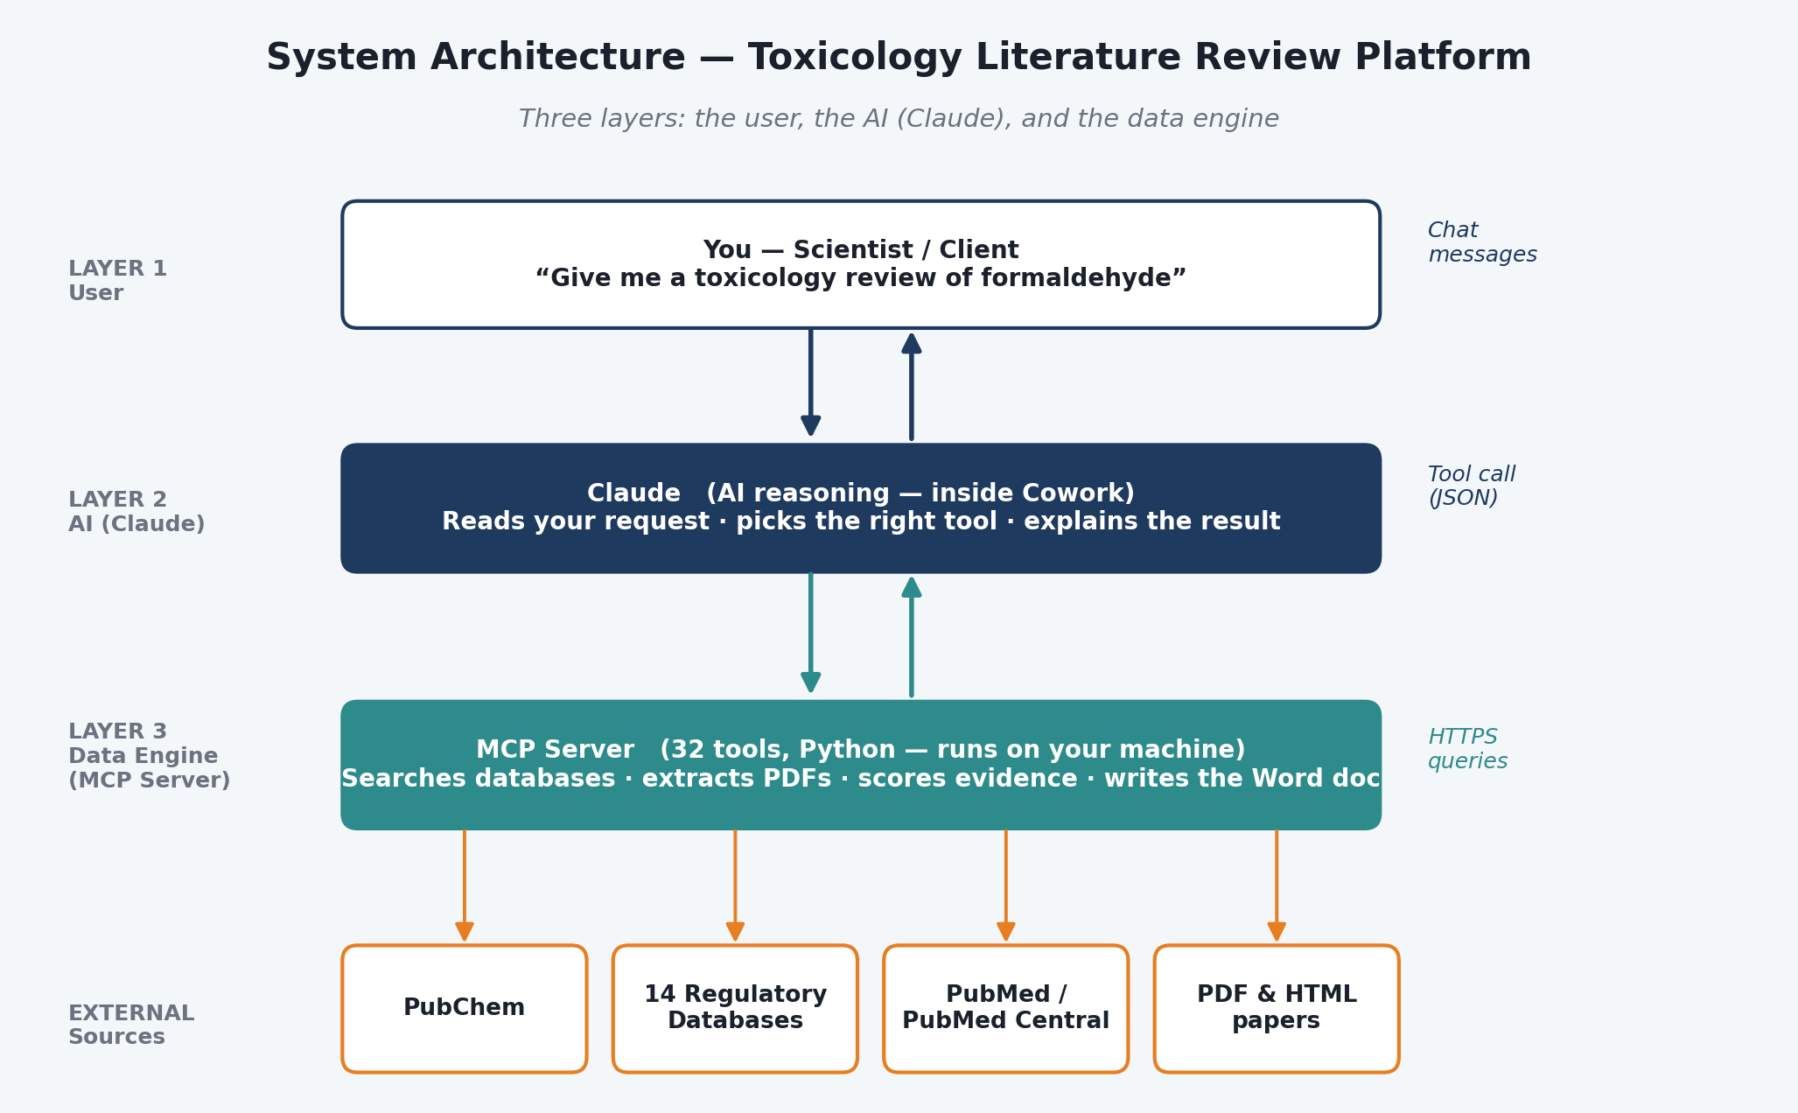
Figure. Three-tier architecture. Claude (top) calls MCP tools (middle), which harvest from public databases (bottom).

Layer 1 — Claude (AI Interface)
Claude is the user's conversation partner. When the user asks for a chemical review, Claude does not guess at an answer from memory. Instead, it selects the build_chemical_review tool from its registered MCP tool list and passes the chemical name as an argument. Claude's role is to route the request — not to invent the content.

Layer 2 — MCP Server (Orchestration)
The MCP server is a FastMCP Python application that registers 32 tools. It handles chemical name resolution, database harvesting, keyword scanning, evidence scoring, and Word-document composition. Each tool is a single, well-defined function with an explicit input schema and return contract, so the behaviour is fully reproducible.

Layer 3 — Public Databases (Data)
The actual scientific evidence lives on the public internet. The MCP server talks to these databases over HTTPS using documented APIs or stable URL patterns. Nothing is scraped from behind login walls. Every URL the system touches is logged so a reviewer can open it directly in a browser.

Why Three Layers?
Separation of concerns
Claude is the assistant that knows what the user wants. The MCP server is the engine that knows how to do the work. The databases are the authoritative source of truth. Keeping these layers separate means Claude can be swapped for a different client, databases can be added or removed, and the scoring logic can be audited independently.

Part 3 — End-to-End Workflow
A single call to build_chemical_review moves through five stages. The user sees one tool call; internally, the pipeline executes each stage in order, emitting progress events to a trace file.
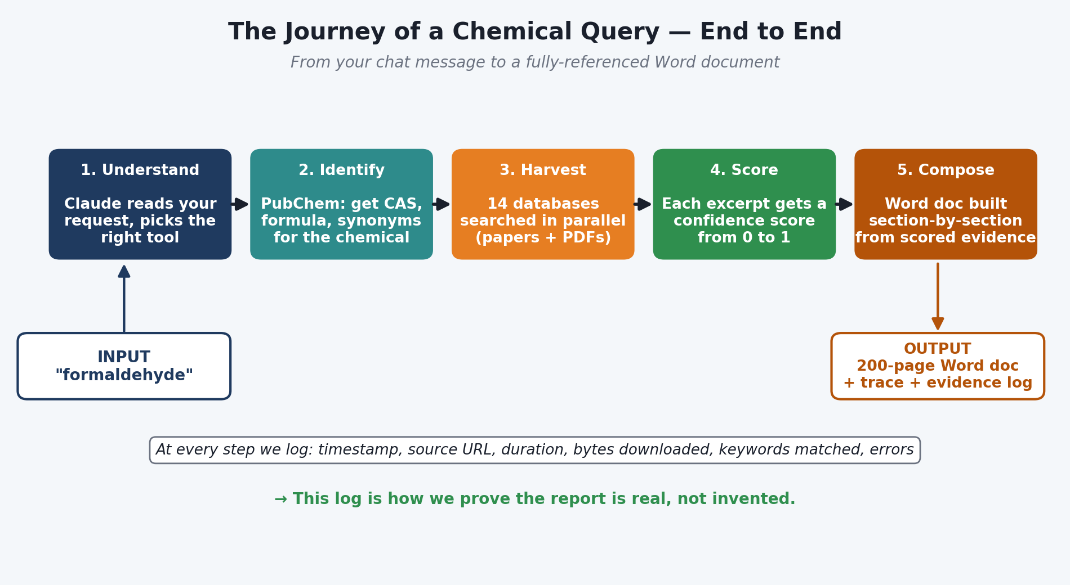
Figure. The five pipeline stages of a build_chemical_review run.

Stage 1 — Resolve
The chemical name is normalised. The platform queries PubChem to retrieve the canonical chemical identity: CAS Registry Number, molecular formula, SMILES, InChIKey, and common synonyms. This means "formaldehyde," "methanal," and CAS 50-00-0 all produce the same run. If PubChem cannot match the name, the pipeline aborts with a clear error — no downstream stage ever operates on an unverified identity.

Stage 2 — Harvest
The MultiDatabaseHarvester fires one asyncio task per database. All fourteen adapters run in parallel, throttled by a shared semaphore (max 8 concurrent HTTP fetches, 16 open TCP connections). Each adapter understands the idiosyncrasies of its database — IARC's monograph pages, PubMed's eutils API, NTP's report landing pages, ATSDR's ToxFAQ structure, and so on.
Each adapter returns a list of document URLs plus short metadata. The harvester does not retrieve the full text at this stage; it builds a deduplicated list of high-value sources.

Stage 3 — Fetch & Scan
For every unique URL, the HTTPFetcher downloads the body (HTML, PDF, or JATS XML), with retries and per-URL caching. The extractor produces clean text. The KeywordSearcher then scans that text for any of the 169 toxicology keywords, building excerpts of plus-or-minus 280 characters around each hit. Up to 8 excerpts are retained per document — enough to capture the salient context without bloating the report.

Stage 4 — Score & Ledger
Every document that matched at least one keyword becomes an EvidenceRecord. The record stores the source URL, title, discovered excerpts, matched keyword categories, and a confidence score between zero and one. Records are appended to the EvidenceLedger, a structured data file that is the single source of truth for the final report.

Stage 5 — Compose
The composer reads the ledger and assembles the Word document. Sections are generated category by category — cancer, reproductive, neurological, hepatic, renal, respiratory, immunological, hematologic, cardiovascular, endocrine — with excerpts grouped by source and confidence. The final file is written to the user's output folder.

Every Stage Is Traced
Throughout the run, a Tracer writes JSON-lines events to a per-run trace file. Every stage start, stage end, HTTP call, keyword match count, and error is logged with timestamps. A reviewer can replay any run after the fact.

Part 4 — The AI Layer: Claude and MCP
This section explains the role of AI in detail, because clients frequently ask: "Is the report written by AI? Can I trust it?" The answer is nuanced and worth unpacking.

Two Distinct Uses of AI
The platform uses AI in two separate, clearly bounded ways. The distinction is critical.

Use 1 — Claude as the Conversation Layer
Claude is the interface. It interprets the user's request, selects the correct MCP tool, and streams results back. Claude does NOT produce the factual content of the report. It is the smart receptionist that knows which office to send you to, not the expert who writes the brief.

Use 2 — Optional LLM Narrative Polishing (on demand)
The platform also exposes four llm_* tools — llm_narrate_section, llm_synthesize, llm_clean_report, and llm_dedupe_paragraphs. These tools wrap a unified OpenAI/Anthropic adapter and can be invoked deliberately, when the user wants an LLM to smooth the prose or merge redundant paragraphs. They are never called automatically.

What build_chemical_review Does NOT Do
Zero LLM calls during harvest
The build_chemical_review pipeline makes exactly zero calls to any language model during its core run. Every word that ends up in the report is either a direct excerpt from a peer-reviewed source or a template string controlled by the composer code. No AI-generated text is introduced during harvest or composition. This is by design — it is the platform's strongest anti-hallucination guarantee.

LLM Tool Inventory
Tool | Purpose | When it runs
llm_status | Reports which provider is configured | On demand
llm_narrate_section | Rewrites a single section in narrative prose | On demand
llm_synthesize | Synthesizes a concise summary across excerpts | On demand
llm_clean_report | Polishes formatting of an existing docx | On demand
llm_dedupe_paragraphs | Merges semantically duplicate paragraphs | On demand

How the LLM Adapter Works
The adapter (core/llm.py) is deliberately minimal: it accepts a system prompt, a user prompt, a max-tokens cap, and a temperature setting, and returns plain text. It selects a provider based on environment variables — TOX_SCRAPER_LLM forces the choice, otherwise the presence of OPENAI_API_KEY or ANTHROPIC_API_KEY is auto-detected. If neither is configured, the llm_* tools return a clear "not configured" error. The rest of the platform continues to work.

Temperature and Determinism
When LLM tools do run, temperature defaults to 0.2 — a low setting that produces more deterministic output. System prompts explicitly instruct the model to quote excerpts verbatim and to flag any uncertainty. The goal is synthesis, never speculation.

Part 5 — The Fourteen Data Sources
The platform draws evidence from fourteen authoritative public databases. Each has a dedicated adapter that knows how to list documents relevant to a given chemical. The harvester runs all adapters in parallel.
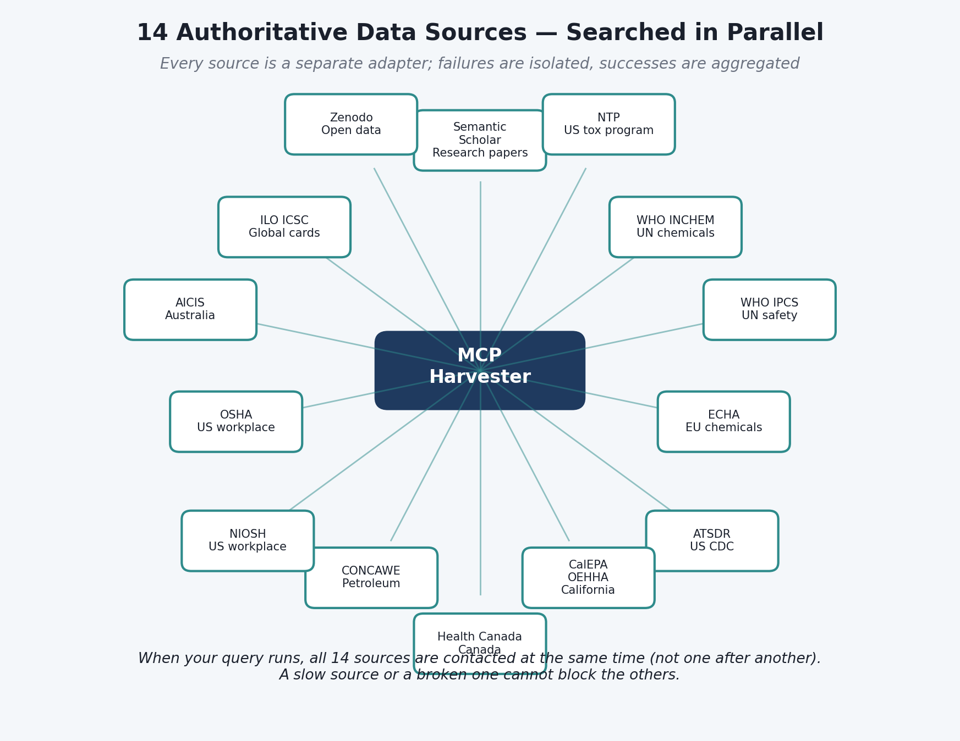
Figure. The fourteen databases queried in parallel during harvest.

Database Coverage
# | Database | What it provides
1 | PubMed / E-utilities | Peer-reviewed biomedical literature
2 | PubMed Central (PMC) | Full-text open-access articles
3 | OpenAlex | Broad scholarly metadata & citations
4 | Semantic Scholar | Academic search with AI-extracted metadata
5 | IARC | Cancer hazard classifications & monographs
6 | NTP | U.S. National Toxicology Program reports
7 | ATSDR | Agency for Toxic Substances toxicological profiles
8 | EPA IRIS | Integrated Risk Information System assessments
9 | OEHHA | California OEHHA health assessments & Prop 65
10 | ECHA | European Chemicals Agency REACH dossiers
11 | WHO / IPCS | WHO environmental health criteria
12 | NIOSH | Occupational-exposure criteria documents
13 | OSHA | Permissible exposure limits & standards
14 | FDA | U.S. Food & Drug Administration safety reviews

How Parallelism Works
When the harvest stage starts, the MultiDatabaseHarvester creates one asyncio task per adapter and awaits them with asyncio.gather. A shared semaphore caps concurrent HTTP requests at 8 across all adapters, and the underlying httpx client is configured with a maximum of 16 open TCP connections. This means fourteen databases are queried simultaneously, but the system never overwhelms a single host or the client's network.

Per-Database Counts Are Reported
Every build_chemical_review response contains a per_database object giving the paper count returned by each adapter. If a database errored — rate-limited, offline, or blocked by a network proxy — the error is captured in per_database_errors and surfaced in the trace, so a reviewer can see exactly which sources contributed and which did not.
Transparency by design
The user does not have to trust that the platform searched every database — the response proves it, with counts and errors line by line.

Part 6 — Anti-Hallucination Safeguards
Language models can fabricate facts. A toxicology report cannot afford fabrications. The platform addresses this with three independent gates, any of which alone would prevent hallucinated content from reaching the user.
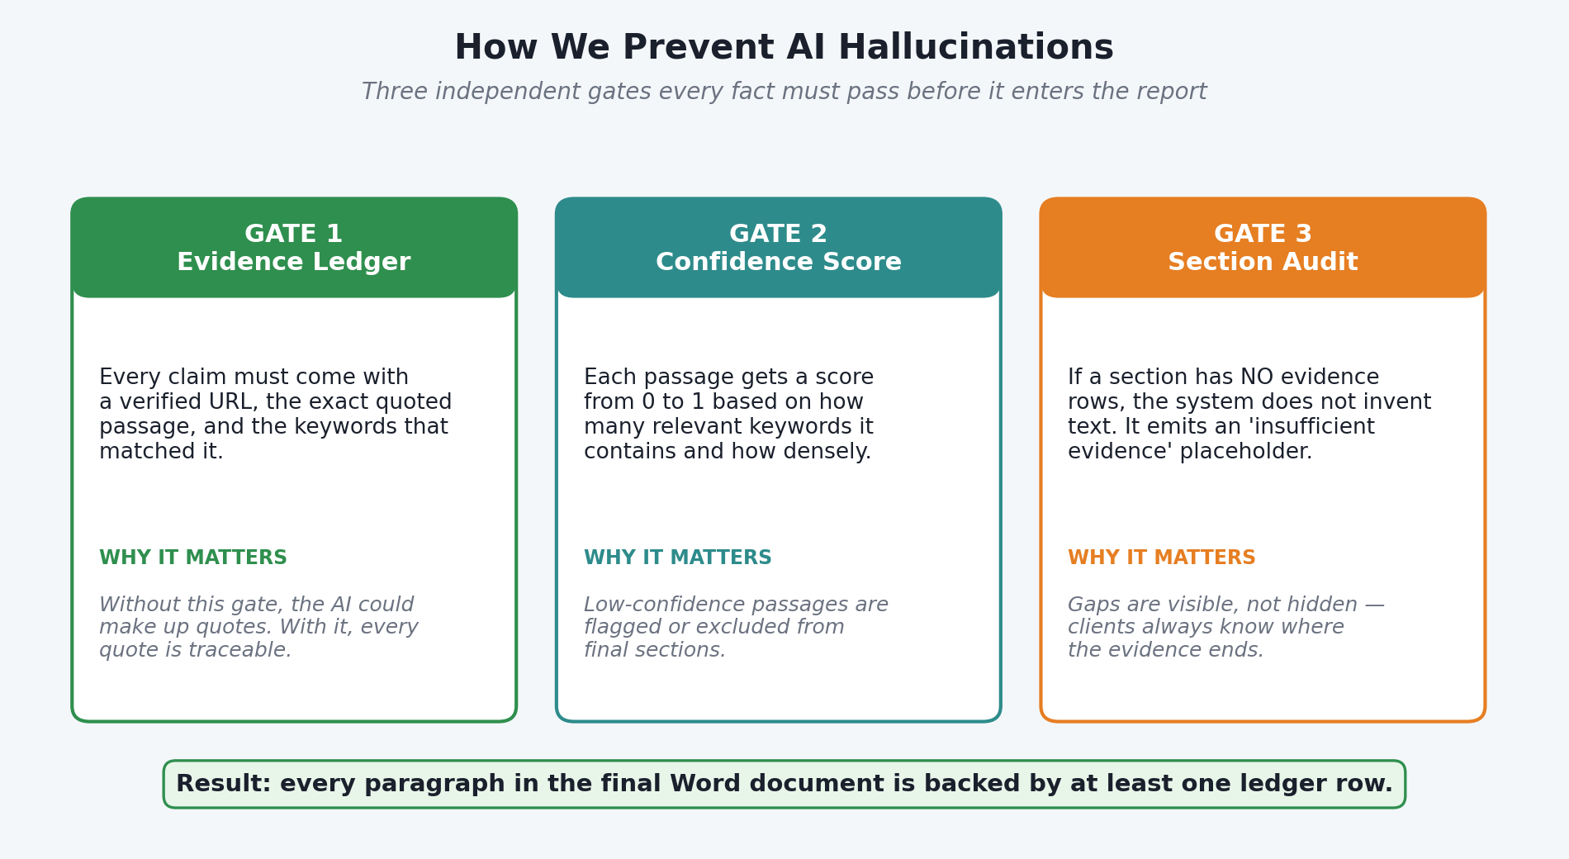
Figure. The three gates that block hallucinated content from the report.

Gate 1 — The Harvest Stage Never Calls an LLM
build_chemical_review does not invoke any language model between stages 1 and 5. Database queries, text fetching, keyword scanning, evidence scoring, and document composition are all deterministic Python code. A hallucination cannot occur in a component that does not use a language model.

Gate 2 — Every Claim Is Anchored to a Source URL
Each paragraph in the output document was generated from an EvidenceRecord. Each record stores the exact URL the text came from, the specific keyword that matched, and the plus-or-minus 280-character window that contained the match. The composer writes the URL next to the excerpt. A reviewer can click any claim and jump straight to the primary source.

Gate 3 — The Evidence Ledger Is Reproducible
The ledger is a persistent JSON structure that records every evidence record produced during the run. Running the same pipeline on the same chemical at a later date produces a comparable ledger, which can be diffed against the earlier one. Every number in the final docx can be traced back to a ledger entry, which traces back to a URL, which traces back to a public database.

What About the Optional LLM Polishing Tools?
When the user explicitly calls an llm_* tool — for example, to smooth a drafted section — the tool is prompted to quote excerpts verbatim and flag uncertainty. Output still must be reviewed by a human before it replaces the deterministic text in the ledger-backed draft.
Reviewable by design
The combination of "no LLM in harvest", "every claim has a URL", and "the ledger is reproducible" means a third-party auditor can verify a report in hours rather than weeks.

Part 7 — Confidence Scoring
Each piece of evidence carries a confidence score between zero and one. The score is not a p-value or a statistical probability; it is a pragmatic blend of two signals that together indicate how relevant and how dense the evidence is for the chemical at hand.
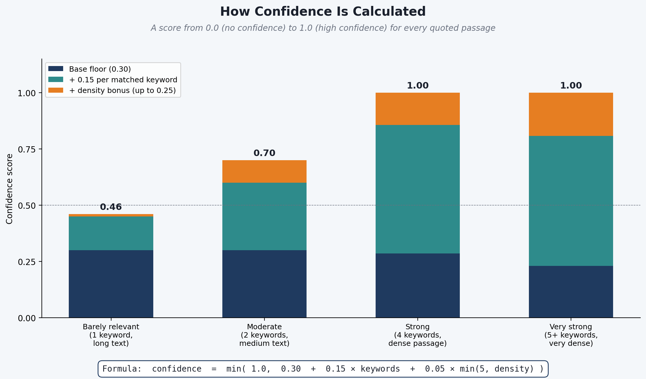
Figure. Components of the confidence score for an evidence record.

The Formula
Confidence formula
confidence = min(1.0, 0.30 + 0.15 x matched_keyword_categories + 0.05 x min(5, keyword_density))

Explained in Plain English
- Base value: Every document that matches at least one keyword starts with a baseline of 0.30.
- Breadth bonus (+0.15 per category): Each additional toxicology category that matches adds 0.15. A document mentioning cancer keywords AND reproductive keywords AND neurotoxicity keywords earns more confidence than a single-category hit.
- Density bonus (+0.05 per hit, capped at 5): Each keyword hit adds 0.05 of confidence, up to 5 hits. Beyond 5, additional hits do not increase the score — this prevents long reviews from dominating just because they are long.
- Ceiling: The score is capped at 1.0. No document can score higher than certain.

Worked Example
A document that matches three categories (cancer, reproductive, neuro) and contains 7 keyword hits scores:
Example
0.30 (base) + 3 x 0.15 (category breadth) + min(5, 7) x 0.05 (density) = 0.30 + 0.45 + 0.25 = 1.00
A document with one category and one hit scores 0.30 + 0.15 + 0.05 = 0.50. Scores below 0.50 are flagged in the report with a "weak evidence" tag, prompting the reviewer to confirm by opening the source directly.

Part 8 — Verification & Quality Assurance
How do we know a report is correct? Three separate mechanisms answer this question, each of which can be checked independently.

Check 1 — The JSONL Trace
Every run produces a JSON-lines trace with one event per line. The trace records every stage start, every stage end, every HTTP call with its status code, every keyword match count, and every error. If a reviewer asks "Why does the report not mention IARC?" the answer is in the trace: either IARC returned zero results for this chemical, or the IARC adapter errored. The trace tells the truth.

Check 2 — The Evidence Ledger
The ledger is a machine-readable record of every EvidenceRecord produced during the run. Each entry has a URL, a category, a confidence score, and the literal excerpts that matched. Diffing two ledgers tells a reviewer how the evidence corpus has changed between runs.

Check 3 — The Docx Validator
The generated Word document is validated through a schema-level validator that catches malformed XML, missing relationships, and non-conformant elements. A run that writes an invalid docx is caught before the file reaches the user.

Reviewer Workflow
- Open the trace file and confirm all stages reached "ok".
- Open the ledger and spot-check the URLs for three random entries.
- Open the docx and verify confidence scores appear beside excerpts.
- If any step is suspicious, rerun build_chemical_review and diff.

Part 9 — Technical Reference
This section lists the exact configuration values used at runtime. Every number here came from reading the source code, not from guesswork.

HTTP Configuration
HTTP client | httpx (async)
Timeout per request | 8 seconds
Retries | 1 per URL
Max concurrent fetches | 8 (semaphore)
Max open TCP connections | 16
User-Agent | SciToVation-TopX-Scraper/1.0
Redirects | Followed automatically
Per-URL cache | Enabled (in-memory, per run)

Keyword Configuration
Total keywords | 169
Categories | 15
Health endpoint categories | 10 (cancer, reproductive, neuro, hepatic, renal, respiratory, immuno, hematologic, cardiovascular, endocrine)
Support categories | 5 (route, pharmacokinetics, study_design, species, agency)
Matching | Case-insensitive substring
Excerpt window | +/- 280 characters
Max excerpts per document | 8

Output Artifacts
Report file | .docx — Microsoft Word
Trace file | .jsonl — JSON lines
Evidence ledger | .json — structured
Output directory (default) | user-configurable via TOX_SCRAPER_OUT_DIR
Report composer | Python ReportGenerator and Node compose_report.js
Node sections | 43 section modules

MCP Tool Surface (32 tools)
The MCP server exposes tools grouped by function. A selection of the most frequently invoked tools appears below.
Group | Representative tools
Pipeline | build_chemical_review, generate_chemical_report, generate_report
Discovery | find_papers, find_papers_openalex, search_in_content
Fetch | fetch_url, fetch_pdf, fetch_pdf_bytes, fetch_pmc_article, fetch_pmc_jats, fetch_agency_profile
Harvest | harvest_database, harvest_all_databases, harvest_references, list_databases, list_harvestable_databases
Extract | extract_links, extract_pdf_figures, extract_pdf_tables
Ledger | build_evidence_record, get_extraction_ledger, reset_extraction_ledger
LLM (on demand) | llm_status, llm_narrate_section, llm_synthesize, llm_clean_report, llm_dedupe_paragraphs
Utilities | resolve_chemical, count_papers_by_database, batch_scrape, build_database_urls

Glossary
A quick reference of terms used in this report. All terms are defined as the platform uses them, not as a general dictionary would.

A–E
- ADI — Acceptable Daily Intake.
- Adapter — A Python module that knows how to list documents in one database.
- ATSDR — U.S. Agency for Toxic Substances and Disease Registry.
- CAS Number — Chemical Abstracts Service registry number; unique identifier for a compound.
- Compose stage — Stage 5 of the pipeline; turns the ledger into a docx.
- Confidence score — A 0–1 rating blending category breadth and keyword density.
- ECHA — European Chemicals Agency.
- EPA IRIS — U.S. EPA Integrated Risk Information System.
- Evidence ledger — The structured record of every evidence entry produced during a run.
- EvidenceRecord — A single data item linking a URL to matched excerpts and a score.

F–N
- FastMCP — The Python framework used to implement the MCP server.
- Harvest stage — Stage 2 of the pipeline; parallel queries to all databases.
- httpx — The async HTTP client library used by HTTPFetcher.
- IARC — International Agency for Research on Cancer.
- JSONL / JSON lines — A file format where each line is a JSON object; used for traces.
- KWIC — Keyword-in-Context; the plus-or-minus-280-character window around a match.
- LLM — Large Language Model. Used only via optional llm_* tools.
- MCP — Model Context Protocol; Anthropic's protocol for tool-using LLM agents.
- NIOSH — U.S. National Institute for Occupational Safety and Health.
- NOAEL / LOAEL — No-Observed-Adverse-Effect-Level / Lowest-Observed-Adverse-Effect-Level.
- NTP — U.S. National Toxicology Program.

O–Z
- OEHHA — California Office of Environmental Health Hazard Assessment.
- OpenAlex — A broad, open-access scholarly metadata database.
- OSHA — U.S. Occupational Safety and Health Administration.
- PMC — PubMed Central; archive of full-text biomedical literature.
- PubChem — NIH database used for chemical-identity resolution (Stage 1).
- Resolve stage — Stage 1 of the pipeline; normalises the chemical name.
- Semaphore — A concurrency-limiting primitive; caps parallel HTTP fetches at 8.
- Tracer — The module that writes a JSONL event log for every run.
- WHO / IPCS — World Health Organization / International Programme on Chemical Safety.

Closing Notes
This report describes the platform as of April 2026. The architecture is intentionally modular: new databases can be added by dropping a single adapter file, new keyword categories by editing a single Python dictionary, and new compose-stage sections by adding a section module. No core change is needed to extend the system.
For technical questions, refer to ARCHITECTURE.md in the source repository, which lists every exact line of configuration. For scientific questions, refer to the evidence ledger that accompanies each report.

— End of Report —

